Java and AWS Training

Day 1 : 14-11-2022

**Program :** set of instruction to perform a specific task.

Structure programming language

OOP : Object oriented programming language

Functional programming language

AOP : Aspect oriented programming language

C: is a basic structured programming language.

#include<stdio.h>

Global declaration

Pre defined function or user defined function.

#include<stdio.h>

void main() {

printf(“Welcome to C language “);

}

Data types

Operators

If statement

Switch statement

Looping

Pointer

Function

Enum

Structure

struct Emp {

int id;

float salary;

char name[10];

};

void main() {

struct Emp e1;

e1.id, e1.salary, e1.name

}

Limitation of procedure language

Data security

Re-usability

void mno() {

}

void xyz() {

mno();

}

void abc() {

xyz();

}

void main() {

abc();

}

OOPs : Object Oriented Programing system

object : object is any real world entity.

Properties or state-🡪 have -🡪 variables / fields

Person

Behavior --🡪 do/does 🡪 functions / methods

Bank

Car

Animal

Customer

Employee

class : blue print of object or template of object or user defined data type which help to create object.

syntax of class

class ClassName {

variable or field declaration;

methods or functions;

}

class App {

public static void main(String args[]) {

System.out.println(“Welcome to Java..”);

}

}

We need to save the program using ClassName.java

Please download java 8 or 11 version

class App {

public static void main(String args[]) {

System.out.println("Welcome to Java...");

}

}

Save the program App.java

javac App.java : compile the program

java App : run the program

class App {

public static void main(String args[]) {

System.out.println("Welcome to Java...");

System.out.println("Welcome to Java...");

System.out.println("Welcome to Java...");

System.out.print("Welcome to Java...");

System.out.print("Welcome to Java...");

System.out.printf("Welcome to Java...");

}

}

Variable : variable is name which hold value and value can change during the execution of program.

Data types: data type is a type of data which tells what type of data it can hold.

It divided into two types.

1. primitive data types : this data types is use to store only value

8 types

1. byte 1byte
2. short 2 byte
3. int 4 byte
4. long 8 byte : without decimal
5. float 4 byte
6. double 8 byte : with decimal
7. char 2 byte : single character
8. boolean 1 bit : true or false.
9. non primitive data types : this data type is use to store value as well as reference of another data types.

4 types

array

class : can pre defined or user defined

interface can pre defined or user defined

enum can pre defined or user defined

type casting :

Converting one data type to another data type is known as type casting.

2 types

Implicit type casting:

Explicit type casting:

------------------🡪 implicit --------------🡪

byte short int long

🡨------------ explicit ------------------------

-----🡪 implicit----------🡪

int float

🡨------explicit ---------

Operator :

Arithmetic operator : +, -, *, /, %

Conditional operator or relational : >, >=, <, <=, ==, !=

Logical operator : &&, ||, !

Assignment operator : =

Increment and decrement : ++, --

Bitwise : &, |, ^

instanceOf

if statement

1. simple if

if(condition) {

}

1. if else

if(condition) {

}else {

}

1. nested if

if(condition) {

if(condition){

}else {

}

}else {

}

1. if else if

if(condition) {

}else if(condition) {

}else if (condition) {

}else {

}

1. switch statement

in switch statement use can take the decision which block we want to execute

syntax

int choice=1;

switch(choice) { // variable type can be int or char or string

case 1:block1;

break;

case 2:block2

break;

case 3: block3

break;

default : default block

break;

}

Taking the value through keyboards in java

using Scanner class.

Scanner is a pre defined class part of util package. Package is a collection of classes and interfaces.

We need to create the Scanner class object

Scanner sc = new Scanner(System.in);

Once we created Scanner class object we will get the error because Scanner is part of util package.

import java.util.Scanner;

looping :it is use to execute the task again and again till the condition become false.

while loop

do while loop

for loop

initialization : start and end position

condition : if true it do the task.

Body of the loop

Increment or decrement

for each loop or enhanced loop : is use to retrieve the value from array or collection of classes.

Day 2 : 15-11-2022

array : array is a type of reference data type which is use to store more than one value of same types.

int a=10;

a=20;

syntax

int abc[];

int xyz[]={10,20,30,40,50};

we can retrieve the value from array index position start from 0.

xyz[0];

creating memory for the array

int data[]=new int[10];

**OOPs concept using Java**

object : object is any real world entity

class : blue print of object or template of object

class name must be follow pascal naming rules.

1. If class name one word. The first letter of class start with upper case.
2. If class contains more than one word then each word first letter.

Variable name and method name must be follow camel naming rules.

1. If variable or method name one word then we have to write in lower case.
2. If variable or method name contains more than one word then from second word onward each word letter must be upper case.

Types of variable or fields.

In Java variable are divided into 3 types.

1. Instance variable:
   1. The variable which declared inside a class but outside method is known as instance variable.
   2. Instance variable hold default value according to their data types.

int family ->0

float family 🡪0.0

boolean 🡪 false

char 🡪space

String 🡪 null;

* 1. Instance variable we can use inside all method directly but method must be part of same class and it must be non static method.

1. Local variable
   1. The variable which declared inside method including main method is known as local variable.
   2. Local variable doesn’t hold default value we have to initialize.
   3. Scope of the variable within that block where it declared.
2. Static variable

Constructor : it is a type of special method which help to create the memory (heap memory).

Pts

1. Constructor have same name as class itself.
2. Constructor doesn’t contains return type not even void also.
3. Constructor no need to call it will call automatically when we create the object.
4. If we not write any constructor by default JVM provide default constructor. Default constructor is always empty constructor.
5. But if we write explicitly empty or parametrized constructor then JVM doesn’t provide any default constructor.

In the life of the object if we want to perform any task only one time that type of task we need to write inside a constructor it can be empty or parameterized.

If we want to do the task more than one time that type of task we have to write inside a method.

Encapsulation : Binding or wrapping data (variables ) and code (methods) in a single unit is known as Encapsulation.

Class is good example for Encapsulation.

class Employee {

String name;

float salary;

void display() {

}

}

this keyword :this is a keyword which refer to current object.

when local variable and instance variable have same name then local variable hide the visibility of instance variable. So if we want to refer to instance variable then we have to use this keyword.

Inheritance : Inheritance is use to inherits or acquire the properties and behavior of old class to new class.

class OldClass { // super class, base class or parent class

properties

behavior

}

class NewClass extends OldClass{// sub class,derived class or child clas

properties

behavior

}

Types of inheritance

1. Single inheritance : one super class and one sub class

class A { }

class B extends A { }

1. Multilevel inheritance : one super class and n number of sub classes connected one by one

class A { }

class B extends A {}

class C extends B{}

class D extends C {}

1. Hierarchical inheritance : one super class and n number of sub classes connected directly to super class.

class A { }

class B extends A { }

class C extends A { }

1. Multiple inheritance : more than one super class and one sub class

class A { }

class B { }

class C extends A,B{ } wrong in Java

Java doesn’t support multiple inheritance using class. It can support using indirectly using interface but not with class.

OOPs relationship

1. is a
2. has a

Day 3: 16-11-2022

OOPs relationship

1. is a relationship
2. has a relationship

class Employee{

id,name,salary

}

class Manager extends Employee{

numberOfEmp

Address add = new Address();

}

class Programmer extends Employee{

projectName

}

class ProjectManager extends Manager{

clientId;

}

class Address {

cit,state etc

}

Manager is a Employee

Programmer is a Employee

ProjectManager is a Employee

Employee/Manager has a Address

Has a relationship : inside one class we are creating object of another class.

Has a relationship types

1. association
2. aggregation
3. composition

class A {

B obj1, obj2, obj3; 0 or 1 or many

}

class B {

A obj1, obj2, obj3; 0 or 1 or many

}

If we want to achieve has a relationship any one of the side we need to create at least one object then we can say has relationship.

class Manager {

Address ladd = new Address(); 0 or 1 or many

Address padd = new Address();

}

class Address {

city, state

}

This is also type of association but it is known as weak association. Weak association is known as aggregation.

class Student {

StudentHistory sh = new StudentHistory();

}

class StudentHistory {

}

This is also type of association but it is known as strong association. Strong association is known as composition.

Polymorphism : one name many forms.

2 types

1. compile time polymorphism or static binding or early binding

Example : Method overloading : method have same name but different parameter list ie type of parameter list or number of parameter list is known as method overloading.

class Operation {

read() {}

add() {}

abc() {}

display() {}

void add(int x, int y) {x+y}

void add(int x, int y, int z) {x+y+z}

void add(float x, float y){x+y}

void add(String x, String y){x+y}

}

1. run time polymorphism or dynamic binding or late binding

Example : Method Overriding : The method have same name and same method signature (number of parameter list, type of parameter list and return type must be same).

To achieve method overriding we need inheritance concept.

Annotation : annotation is known as meta-data. Data about data.

Java provided lot of pre defined annotation as well as we can create user defined annotation.

All annotation start with pre-fix @ followed by annotation name

If annotation we can use on class level or method level or property level.

@Override annotation we can use on those method only which are methods are override.

Java Non access specifiers

abstract, static and final

abstract : abstract is keyword we can use with method and class but not with variable.

1. abstract method : the method without body or incomplete method or without curly braces is known as abstract method

abstract void speed();

1. if class contains one or more abstract method then that class we need to declare as abstract class.

abstract class Bike {

}

1. Which ever class extends abstract class that class must be provide for all abstract method belong to that class.

That class can ignore if that class itself is an abstract class.

1. We can’t create abstract class object.
2. Abstract class can contains normal as well as abstract method.

It can contains zero or 1 or all abstract method.

1. class can be abstract but no abstract method.
2. abstract class can contains default as well as we can write parameterized constructor(this constructor is use to set the value for instance variable).

static

1. static keyword we can use with variable and method but not with class (we can use static keyword with class but class must be inner or nested class). Outer class we can’t use static keyword.
2. Static variable :if variable is static we can access or assign the value for that variable using class name.
3. Static method : if method is static we can call that method with help of class name object not required.
4. Even though we can assign the value for static variable with object also as well as we can call static method with the help of class name.
5. Inside non static method we can access static as well as non static variable directly but inside static method we can access only static variable directly of that class.

heap memory

static memory

every class we will get only one static memory

Employee

Id,name,salary - 🡪 instance variable

MgrId,ClientId,ProjectId; 🡪 static

Static is like a global to all object.

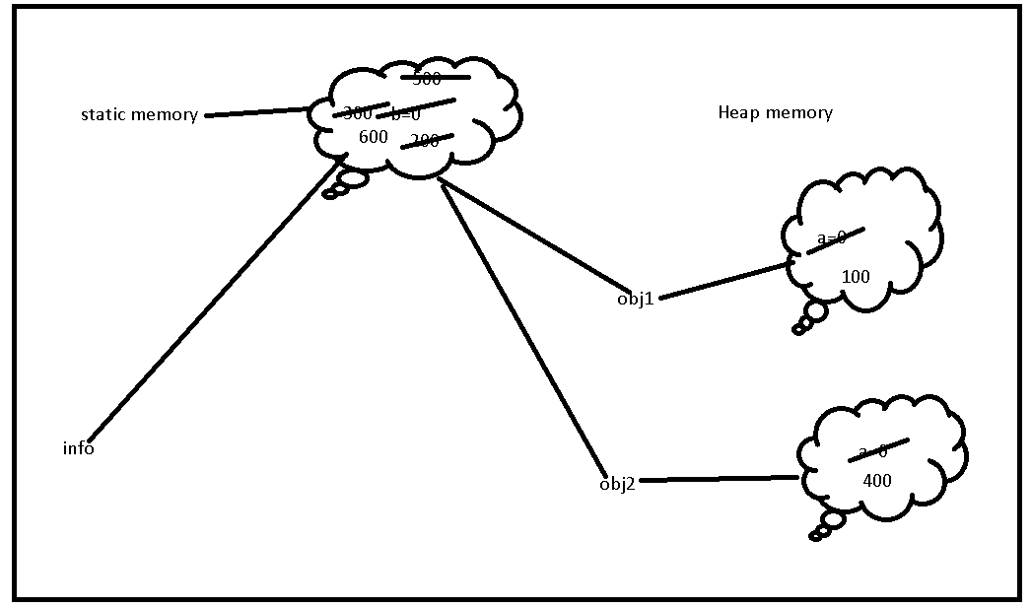

Day 4 : 17-11-2022

final keyword :

1. Final keyword we can use with variable, method and class
2. final variable : we can use final variable to declare constant in java.

final int A=10;

A=20; //Error

1. final method : if method is final we can’t override that method but we can use it or we can call it in sub class.
2. final class : if class if final we can’t inherits or extends that class.

interface : interface is a type of reference data types which is also known as 100% pure abstract class.

Syntax to create interface

interface interfaceName {

fields;

methods;

}

By default all fields in interface are public static and final

By default all methods in interface are public and abstract.

interface Abc {

public static final int A=10;

public abstract void dis1();

}

interface Abc {

int A=10;

void dis1();

}

interface Xyz {

int B=20;

void dis2();

}

interface Mno extends Abc,Xyz{ // multiple inheritance.

int C=30;

void dis3();

}

class Info implements Abc,Xyz {

need to provide body for dis1 and di2

}

Like a class one interface can extends another interface. But interface can extends more than one interface.

Class always implements interface. Class can implements more than one interface. Which ever class implements any interface one or more than interface must be provide the body for all abstract method belong to that interface.

Access specifiers while overriding interface method

Super class / interface Sub

public public

protected public

protected

default (nothing) public

protected

default (nothing)

private we can’t override method

difference between interface and abstract class.

1. Interface contains only final variable but abstract class not mandatory.
2. Interface contains only abstract method but abstract class not mandatory it can contains abstract as well as normal method.
3. Interfaces doesn’t contains default constructor as well as we can’t write parameterized constructor. But abstract class can contains.
4. We can implements more than one interface but we can extends only one abstract class.

Common points

1. We can create the object of interface as well as abstract class.
2. Whichever class extends abstract class or implements interface that must be provide the body for all abstract method belong to that interface or that abstract class mandatory.

Using abstract class we can achieve partial abstraction but using interface we can achieve 100% abstraction.

Abstraction :hiding the internal implementation without knowing background details.

Run time polymorphism using object creation.

this keyword, super keyword, this(), super()

this() and super() :these two use to do constructor code re-usability.

this() : it is use to achieve constructor chaining or calling the same class constructor. this() must be inside a constructor and it must be first parameter inside a constructor.

super(): it is use to achieve constructor chaining from sub class constructor to super class constructor. By default every sub class constructor contains super() parameter which always call super class empty constructor. And it must be first parameter inside a constructor.

Day 5 : 18-11-2022

EmployeeName_EmployeeId_Week1.zip

Access specifiers : java provided different types of access specifiers which help expose the visibility of classes, interfaces, variable and methods.

Four types of access specifiers

1. **private**

We can use private with : instance variable, static variable, non static method, static method, constructor but can’t use local variable and class(outer class).

**scope** : within a same class.

1. **default (nothing)**

We can use default with all.

**scope** : within same package other package we can’t access.

1. **protected**

We can use protected with : instance variable, static variable, non static method, static method, constructor but can’t use local variable and class(outer class).

**scope** : within a same package other package if class is sub class or inherits class.

1. **public:**

We can use with call but not with local variable.

We can use with class but in one editor or file if we write more than one class we can use for only one class as public other class must be default.

**scope** : same package as well as other package.

package : package is known as collection of classes and interfaces.

When two classes or interfaces which have same name but different purpose use then using package concept we can avoid the conflict.

Package is like directory or folder.

Package are divided into two types.

1. User defined package or custom package
2. Pre defined package or built packages.

education

school college

Attendance.java Attendance.java

Syntax to create the package

package packagename;

import packagename.subpacakge.*;

import packagename.subpackage.ClassName;

pre defined package

pre-defined package

java -----🡪 root package javax -🡪root package

lang swing

io servlet

util ejb

sql sql

net net

etc

by default every java program imported lang package.

import java.util.*;

import java.util.Scanner;

import java.*; wrong

Scanne sc = new Scanner(System.in);

Lang package classes and interfaces

Exception, Error and more types of exception classes.

Thread , Runnable

String

StringBuffer

StringBuilder

Object -🡪 by default every java program it may be pre defined or user defined extends Object.

Class : name of class itself is Class.

Wrapper classes

Cloneable interface. : this interface is use to create Clone or duplicate object.

System

Day 6 : 21-11-2022

**Exception handling :**

Exception is a pre defined object or memory which occurs when unexpected or abnormal conditions occurs during the execution of a program. Using some technique we need to handle exception that is known as exception handling.

Java

Compile program run the program

javac : compiler java : interpreter

compile time error run time error

syntax error

or typo error error exception

run time error

Object

Throwable

Error Exception

Both are pre defined classes part of lang package. Error and Exception extends Throwable class. Throwable class internally extends Object.

Error : The error which generate at the run time which we can’t handle it. Ex: JVM crash, software or hardware etc.

Exception : exception is type of run time error which we can handle it. Ex: divided by zero.

Exception

CheckedException UncheckedException

IOException RuntimeException

SQLException

ArithmecticException

ArrayIndexOutOfBoundsException

All unchecked exception are sub class of RuntimeException.

To handle both the type of exception java provided 5 keyword.

1. try
2. catch
3. finally
4. throw
5. throws

Unchecked exception

try catch block (try with single catch block)

try {

}catch(Exception e) {

}

Try with single catch block

If we want do common task if any exception generate then we can use try with single catch.

If we don’t know which code generate what type of exception.

Try with multiple catch block :

Base upon exception we want to execute set of code and we know which code generate type of exception then we need use try with multiple catch block.

finally block

This block execute 100% sure if any exception generate or not. It will execute doesn’t matter any exception generate or not.

Catch block execute only if any exception generate. It is known as exception handler.

In try block we need to write the code which may generate exception.

It is use to close the resources like file handling, jdbc connectivity etc.

try

catch catch catch catch finally

catch finally catch

catch finally

try{

open file

read and write operation

}catch(Exception e) {

}finally {

close the file

}

throw : This keyword is use to throw checked or unchecked user defined or custom as well as pre defined exception base upon our conditions. With help of throw keyword we can raise or generate any exception

syntax

throw new Exception();

or

throw new ExceptionSubClass()

throws : this keyword is use to throw checked or unchecked exception to caller method.

This keyword we use with method signature.

void display() throws Exception, ExceptionSubclass {

}

Checked exception check twice one at compile time and another run time.

Unchecked exception we can avoid some extends but checked exception we can’t avoid because we can’t compile the program.

We need to handle the checked exception mandatory using try – catch or throws.

Introduction to Multi threading

**synchronization**

program : set of instruction to perform a specific task.

process : time taken to execute the code.

processor : processor is responsible to execute the code.

thread : thread is a small execution of a code within a process.

By default java is thread base programming language.

Thread t = Thread.currentThread();

System.out.println(t); Thread[main,5,main];

Main 🡪 name of the thread

5 🡪 priority of the thread

Main 🡪 group of thread

Inside a main method by default one thread always execute to that thread details we can take the help of currentThread.

Multi tasking using two ways

1. using process base
2. using thread base

In Java we can create user defined thread using two ways

1. Extends Thread class
2. Implements Runnable interface

Synchronization : it is a concept which help to allow to access all resource or particular resources for only one thread at time in particular period of time or it is use to block or lock the thread.

To achieve synchronization we need to use synchronized keyword.

This keyword we can use with method or inside a method we can use more than one synchronized block.

When method is synchronized work is thread safe but slow in performance.

Day 7 : 22-11-2022

String class : String is one character or more than one character enclose in double quote. In Java String is pre defined class or also known as reference. In Java String doesn’t end with null character.

Syntax to create the String class object.

String str1 = “Welcome to Java”; literal style object creation

String str2 = new String(“Welcome to Java”); using new keyword.

str1.

StringBuffer

StringBuilder

In String

== : it check value as well as reference code or memory code or hashcode

equals() : it check only value not reference code.

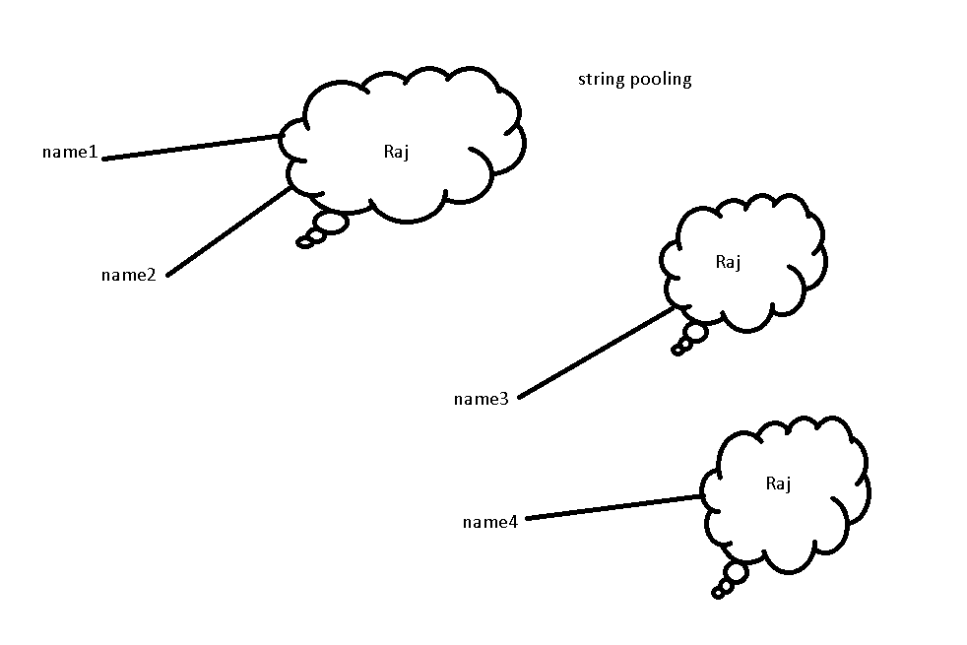

String is known as immutable class. We can’t change.

StringBuffer

StringBuilder

These two classes is known as mutable string class.

StringBuffer method are synchronized means they are thread safe but slow in performance.

StrinigBuilder method are not synchronized so they are not thread safe but performance wise fast.

Wrapper classes : Java provided totally 8 types of wrapper classes which help to convert primitive to object and vice-versa.

Primitive data types Wrapper classes

byte Byte

short Short

int Integer

long Long

float Float

double Double

char Character

boolean Boolean

byte a=10;

int b=20;

Integer c = new Integer(b); : converting primitive to object.

int d = c.intValue(); : convert object to primive

float e = c.floatValue();

JavaBean class :

According to Java bean class

1. Class must be public
2. All variable must be private and for each variable we need to provide setter and getter method.
3. Setter method name start with pre-fix set followed by variableName like setId
4. Getter method name start with prefix get followed by variable name like getId
5. Setter method is use to set the value with condition base upon requirement.
6. Getter method is use to get the value.

This class is known as pure encapsulation class.

Whenever we display any user-defined class reference using println internally it will to toString() of object class and that method return as a string ie [packageName.className@code](mailto:packageName.className@code).

But if we need proper output then we need to override toString method belong to object class.

equals() method is part of Object class. String class as well as all wrapper class override equals() method. They provided the logic how to compare to String as well as wrapper class reference.

When we check user defined class reference with equals method it will call equals() method of object. that equals method return false by default.

Now we need override equals method and inside that method we need to provide logic for equal when two object are equal base up property like id or name or salary or all

Clone : clone is use to create the duplicate object.

To create the clone java provided clone() method this method is part of Object class.

Which class object we want to create clone that class must be implements Cloneable interface. This interface is part lang package. This interface is known as marker interface. Marker interface means this interface doesn’t contains any method or zero methods.

Day 7 : 23-11-2022

IO : Input and Output : In Java We can do IO operation using stream.

Stream means flow of data or it is abstraction between source and destination.

Stream

byte char

Input Output input output

InputStream OutputStream Reader Writer

These are abstract classes part of io package.

DataInputStream DataOutputStream InputStreamReader OutputStreamWriter

FileInputStream FileOutputStream FileReader FileWriter

ObjectInputStream ObjectOutputStream BufferedReader BufferedWriter

PrintStream PrintWriter

Scanner sc = new Scanner(System.in);

System.in()

System.out.println(“”);

System is a class which contains three reference ie in, out and err

In is reference of InputStream

Out and err is reference of PrintStream

These 3 are property of system.

InputStream is = System.in; InputStream always refer to standard input device ie keyword.

PrintStream ps = System.out; PrintStream always refer to standard output device ie console

Byte wise

Source : keyword

Destination : console

But if we want to store primitive data types like id,name,salary,desg etc.

FileInputStream, DataInputStream, DataOutputStream,FileOutputStream

So if want to store the object.

Object Serialization : object contains three things

Identity ie reference of that object

Property : variable of that object

Behavior : functionality of that object

We can store only property not identity as well as functionality.

Storing the object itself or converting object into byte format is known as object serialization.

Object De-Serialization : converting byte format object back object format is known as object De-serialization.

Which class object we want to do serialization that class must be implements Serializable interface and it is a type of marker interface.

Day 9 : 24-11-2022

Collection Framework (Data Structure)

Variable

int a=10;

a=20;

array

int abc[]={10,20,30,40};

structure like In C or C++

Java doesn’t support structure

class Employee {

int id;

String name;

float salary;

}

Employee emp = new Employee();

emp.id = 100;

emp.name =“Ravi”;

emp.salary = 12000

array object

Employee emp[]=new Employee[100];

emp[0];

emp[99];

array which can hold primitive or user defined object.

limitation

fixed in memory size.

Array object doesn’t provide any pre-defined method which help to add, remove, search, iterate one by one.

Collection framework provide set of collection of classes and interface which help to add the collection of object or elements of any type (like int, float, char, string as well as user defined object).it provided lot of pre defined method which help to add, remove, search, iterate one by one very easily.

Collection hierarchy

All collection framework classes part of util package.

Collection --🡪 interface

Extends

List Set Queue Map🡪 interface

List : it maintain the order using index position. List allow duplicate.

List API (Application Programming Interface). It may classes and interface.

ArrayList

LinkedList

Vector

Stack

Set : it doesn’t allow duplicate. In Set few API maintain order, unorder or sorted.

HashSet

LinkedHashSet

TreeSet

Queue : Queue First in First Out operation we can do using Queue.

PriorityQueue

LinkedList

Map : it allow to store the data in key-value pairs. Key is unique and value may be duplicate.

HashMap

LinkedHashMap

TreeMap

Hashtable

Deque: it is a type of interface which extends Queue interface.

ArrayList : ArrayList is a type of list api we can add same as well as different types of values by default.

Normal Array is known as fixed memory size we can store same type of value. Adding and removing elements from normal array more complex.

ArrayList allow to store any types of values. It is known dynamic memory and we can add or remove elements very easily.

LinkedList : In Java LinkedList is a type of list API. Whenever we store the elements in LinkedList is use node concept.

LinkedList mainly divided into 3 types

Single LinkedList

Double LinkedList

Circular linked List

In Java by default Linkedlist consider as double linked list.

**Vector** : it is a type of legacy class. By default all method in Vector class are synchronized. Default size of vector 10. Vector once the size 10 cross it will increase by default 100% in ArrayList it will increase by default 50%

Stack : Stack is a type of data structure which help to do the operation as First In Last Out. Stack extends Vector. We can say Stack is a type of List API.

Queue : First in First Out

PriorityQueue : first in first out base up on priority

LinkedList : first in first out

Map : it allow to store the data in key-value pairs.

**HashMap :** Implements Map interface . it can allow null key but only one we can store more than one null value. In HashMap display element randomly.

**LinkedHashMap :** Is it sub class of HashMap as well as implements Map interface. It maintain the order. . it can allow null key but only one we can store more than one null value. In HashMap.

**TreeMap :** implements NavigableMap and this interface extends SortedMap interface. In TreeMap it display the element ascending order as a key. In TreeMap we can’t store key as null but it can allow null value. In TreeMap key must be same type because this class internally implements SortedMap interface and that interface provide sorting algorithm.

**Hashtable :** it implements Map interface. Hashtable is legacy API and all method in Hashtable are synchronized. In hashtable we can’t store null key as well as null value. It display the element in unorder.

**Set :** Set doesn’t allow duplicate. Set doesn’t provide index position.

Set API

HashSet : it implements Set interface and it hold element unorder. It allow null value as well as by default we can store any type of values.

LinkedHashSet: It extends HashSet interface and maintain the order. It allow null value as well as by default we can store any type of values.

TreeSet : TreeSet indirectly implements SortedSet interface. Because of this reason in TreeSet we have to store same type of values. It doesn’t allow null value.

Retrieving the value from collection API one by one

1. For each loop
2. Iterator interface : only forward direction
3. ListIterator : forward as well as backward direction.
4. Enumeration

Collection framework with generics

Day 10 : 25-11-2022

Collection framework with complex object.

Collection utilities classes

**Arrays**

**Collections**

Both these classes is known as utilities classes which prove set of static method help to do some operation in primitive array as well as list api.

Arrays which provide set of methods to do some operation on primitive array of int, char, float, double, string etc.

Collections.sort(listRef);

If that list reference hold primitive value as well as string value then we will not get any error.

Because by default all Wrapper as well as string class internally implements Comparable interface. Comparable is interface part of lang package. That interface contains compareTo method which is responsible to do sorting.

When we pass list reference sort method expect that class which hold by list must implements Comparable interface reference.

When we pass list reference and list hold the user defined class object then we will get the error because user defined class by default doesn’t implements Comparable interface. So to avoid the error no our user defined class must be implements Comparable interface and provide the body for compareTo method.